Odoo CRM Upgrade Issue:

**PROBLEM:**

* The Issue Is that when we try to hit the upgrade button in CRM Module in Odoo, our Odoo server that is currently running gets crashed and throws an **"Odoo 500 Internal Server Error”**in browser.
* So, we cannot able to update or uninstall that module. we went to Log Files and read the whole log and found out the ERROR.

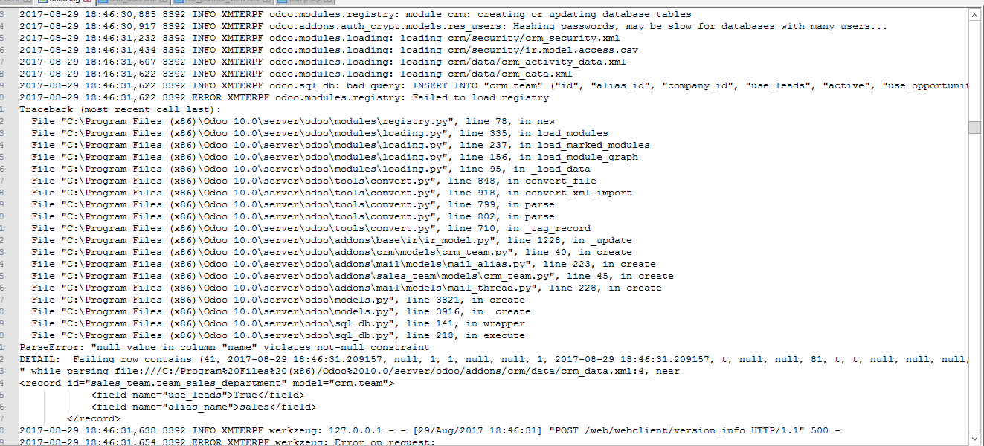

**Fig 1.0 – Log File**

**Root Cause of the Problem:**

* The seed data which is present in crm.team has been unfortunately deleted.
* The seed data is nothing but the Direct Sales which is a default data of CRM team.

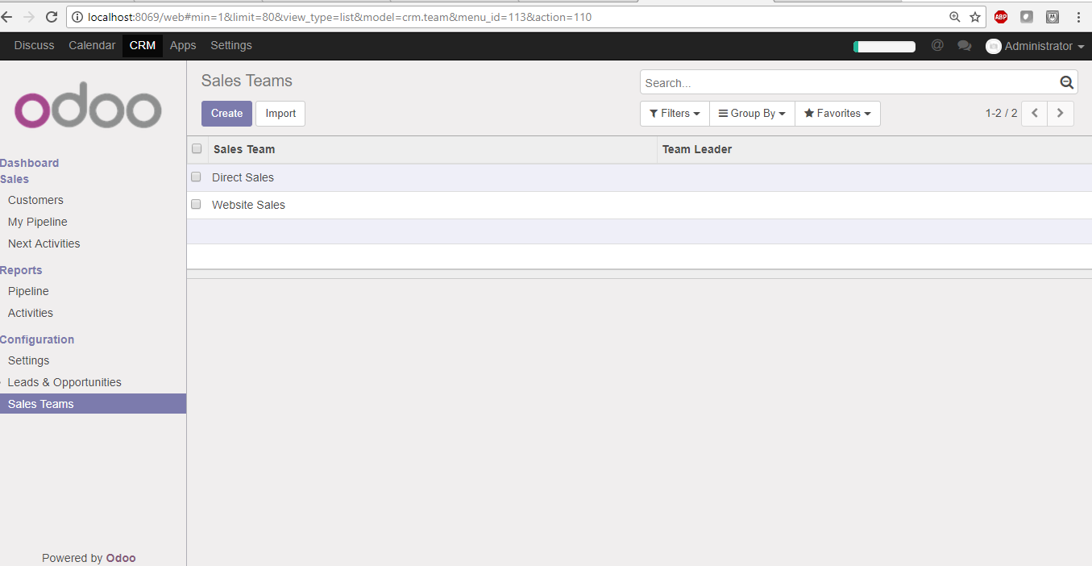

**Fig 1.1 – Direct Sales**

* The CRM should contain the default data as in figure 1.1.

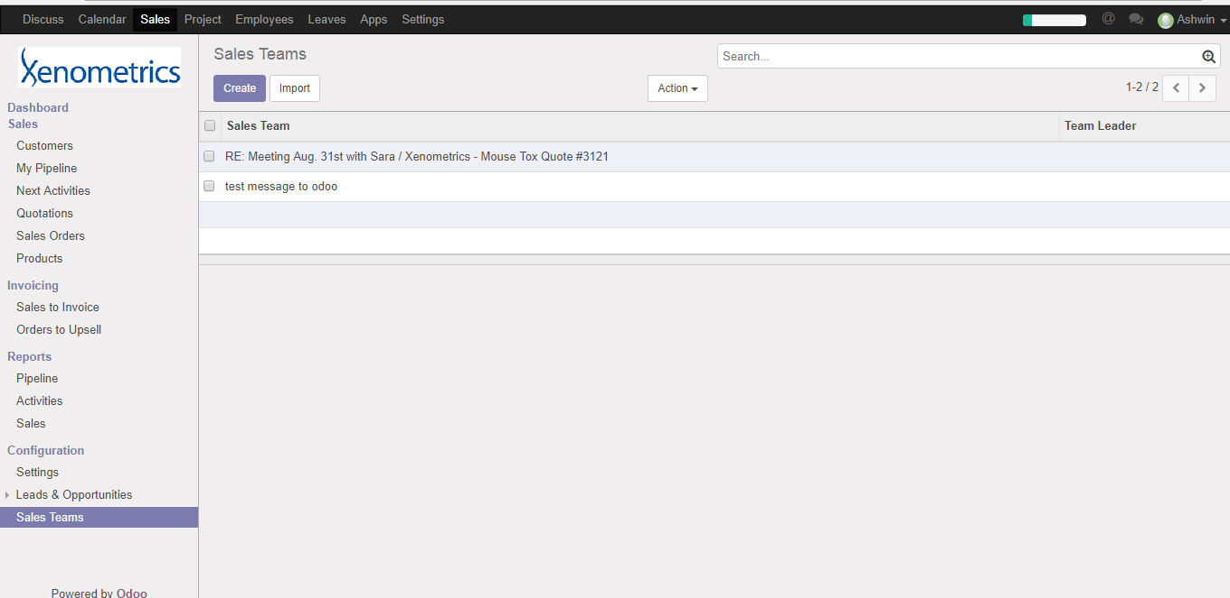

**Fig 1.2 – Deleted Direct Sales**

* The Figure 1.2 shows that the default CRM data has been deleted.

**APPROACH & FIX:**

* We need to regenerate the seed data for CRM team (Direct Sales).
* In generic when we hit the CRM upgrade it will insert the seed data which doesn’t exists in the table.
* So, once disabling the Null value constraints it will now generate the Sales CRM team name with NULL Value. Now we have renamed the name column to Direct Sales.
* Finally, we again enabled the Not Null constraint back and upgraded the CRM module, it gets upgraded successfully.
* This is the Permanent Solution for Current production and to the new production.

**Warning:** Do Not delete the seed data.

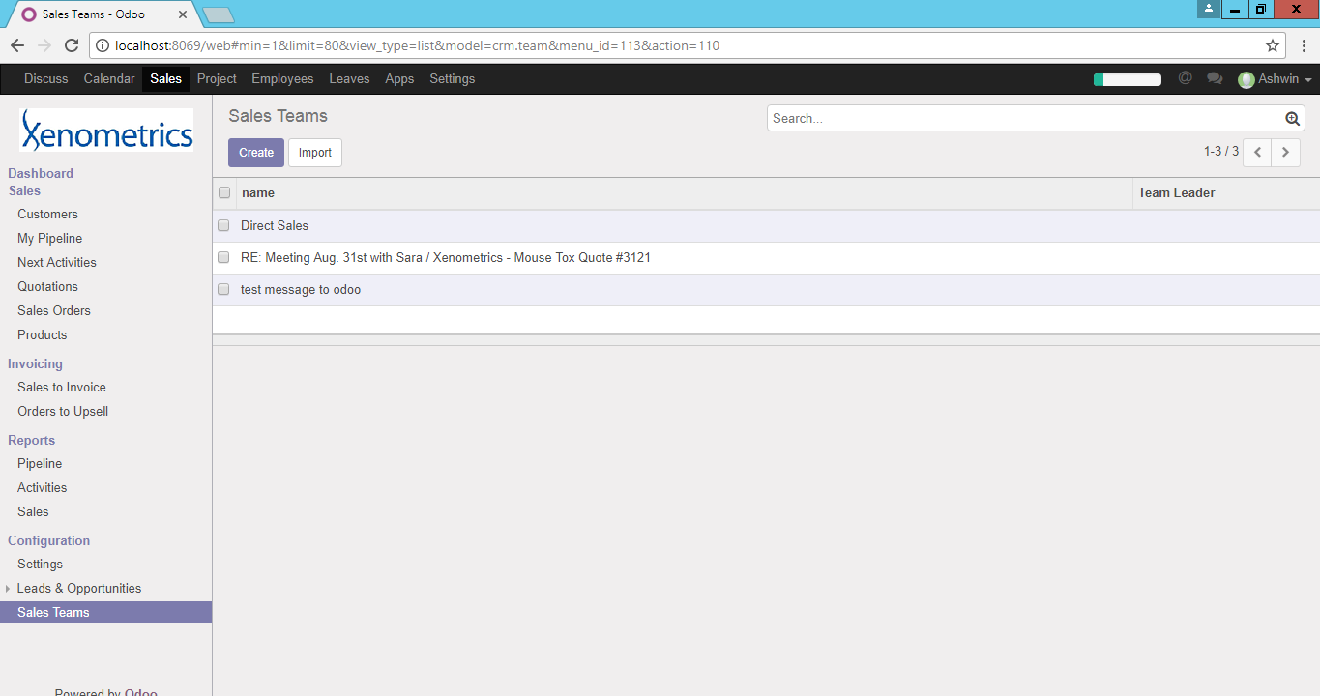

**Fig 1.3 – Restored the Direct Sales in Production machine**